Final Assessment-Alternative Assessment
Semester | 202520 | Division | CIS
Assessment title in Syllabus | Final_Project_Portfolio | Program | Bachelor of Information Technology/ Bachelor of Information Systems
Course Code | CDS 2413
Course Title | INTRODUCTION TO DATA SCIENCE
Course Instructor |  | CRN
Assessment | Project Deliverable 2 – Machine Learning Model Report | Submission Date | Week 13
Student Declaration:
Academic Integrity Statement
In accordance with the HCT Academic Integrity Policy
• Students are required to refrain from all forms of academic integrity breaches as defined and explained by HCT.
• A student found guilty of having committed acts of academic integrity breach(es) will be subject to the relevant sanctions as outlined by HCT.
إفادة النزاهة الأكاديمية
وفقًا لسياسة كليات التقنية العليا للنزاهة الأكاديمية
• على الطلبة الإلتزام بلوائح وقواعد النزاهة الأكاديمية، كما هو مبيّن وموضح في السياسات والإجراءات الخاصة بكليات التقنية العليا.
• في حالة ارتكاب الطالب أي شكل من أشكال الإخلال بالنزاهة الأكاديمية، سيتعرض الى العقوبات الموضحة في السياسات ذات الصلة.
This assignment is entirely my/our own work except where I have duly acknowledged other sources in the text and listed those sources at the end of the assignment. I have not previously submitted this work to the HCT, or any other entity. I understand that I may be orally examined on my submission.

Student HCT ID(s): | H00468893 | H00534370 | H00495372 | H00
Student Name(s): | Naema Hussain | Aaesha khaled | Shaikha Ali
Student Signature
Chatbot (e.g. ChatGPT) statement
This submission allows you to use AI generated tools, but the prompt used must be stated and the response must be in red font. Include References to ChatGPT.

Instructions

Remove instructions and hints from the template before submitting the final report to BBLearn.

CLO3: Machine Learning Model (25 Points)

Preprocessing(5 Points)

Data Collection (1 Point)
<< Which Python libraries can be used to read data from CSV or Excel files? How will you identify and separate the dependent and independent variables from the dataset? >>

We used Python libraries such as:

- Pandas → to read CSV files (pd.read_csv())
- NumPy → for numerical operations

To separate variables:

- Dependent Variable (y): Selling_Price
- Independent Variables (X):
  - Year
  - Present_Price
  - Kms_Driven
  - Fuel_Type
  - Transmission
  - Owner

Data Cleaning (1 Point)
<< What strategy or strategies did you use to clean your dataset? Provide examples, such as filling missing values with the mean or removing duplicates.>>

The dataset was cleaned using the following strategies:

- Handling Missing Values:
The dataset was checked and no missing values were found, so no imputation was required.
- Removing Duplicates:
Duplicate rows were removed using drop_duplicates().

- Outlier Removal:
Outliers were detected using IQR method and removed.

Treating the Categorical Variables (1 Point)
<< What types of categorical variables (nominal, ordinal, or binary) are present among your dependent and independent variables? What encoding technique did you use for these variables, and why?>>
Types of categorical variables:
- Fuel_Type → Nominal
- Transmission → Binary

Encoding used:
- One-Hot Encoding for Fuel_Type
- Label Encoding for Transmission

Reason:
- To convert categorical values into numerical format for machine learning models.

Splitting the Dataset (1 Point)
<< Why is it important to split the dataset during model development? What proportion did you use for training and testing, and why?>>

The dataset is split to:
- Avoid overfitting
- Test model performance on unseen data

Split used:
- 80% Training
- 20% Testing

Featuring the Dataset (1 Point)
<< Did you apply feature scaling to your dataset? If so, which technique did you use, and why? If not, explain your reasoning.>>

Yes, feature scaling was applied using StandardScaler.

Feature scaling is important for models like Ridge, Lasso, Elastic Net, and KNN, as these models are sensitive to feature magnitude.

However, scaling is not required for tree-based models like Decision Tree and Random Forest.

Regression Model (7 Points)

Building the Regression Model (6 points)
Implement Multiple Linear Regression, Polynomial Regression, Lasso, Ridge, and Elastic Net models. Select the best-fitting model based on evaluation metrics(R-squared). Analyze the model's performance by comparing predicted value with the actual values in the dataset.

In this project, regression models were used to predict the dependent variable (Selling_Price) based on independent variables such as Year, Present_Price, Kms_Driven, Fuel_Type, Transmission, and Owner.
Regression is a supervised learning technique used when the target variable is continuous. It helps in identifying relationships between variables and predicting numerical outcomes.

Steps to be followed:

1. Loading and Preprocessing the Data
- Load Dataset:
  - The dataset (Marks.csv) is loaded using pandas.
  - Relevant columns (Quiz, Practical, Project, Final) are extracted for analysis.
The dataset (Car-Price.csv) is loaded using the Pandas library in Python. This allows efficient handling and analysis of the data.
Relevant columns were selected for analysis, including:
- Selling_Price (dependent variable)
- Year
- Present_Price
- Kms_Driven
- Fuel_Type
- Transmission
- Owner
These columns are important as they directly influence the selling price of the car and are used to build the regression model.
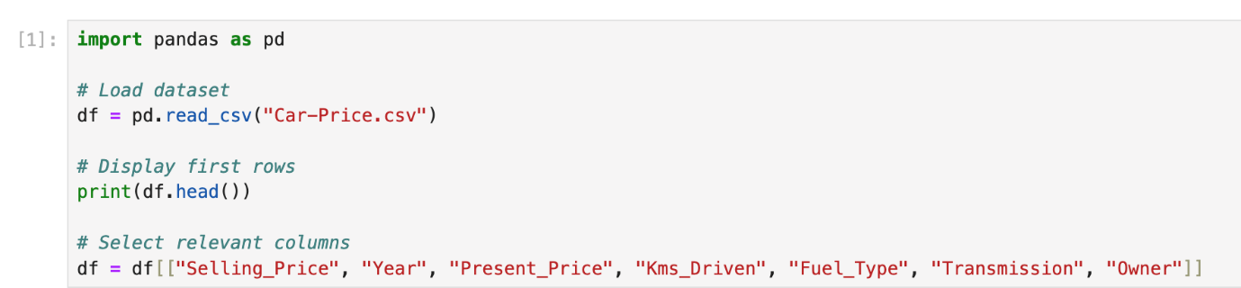
- Handle Missing Values:
  - Missing values in the selected columns are replaced with their respective column means to ensure the dataset is complete and usable for modeling.
The dataset was checked for missing values in all selected columns. It was found that there were no missing values present in the dataset.
Therefore, no imputation or replacement was required, and the dataset was already complete and ready for further analysis and modeling.

- Create Target Variable:
  - A new column, Total, is computed as a weighted sum of the independent variables:
    - Total = 0.1 * Quiz + 0.3 * Practical + 0.3 * Project + 0.3 * Final.
he target variable is Selling_Price, which represents the price of the car and is used directly for prediction.
The independent variables used to predict the target include:
- Year
- Present_Price
- Kms_Driven
- Fuel_Type
- Transmission
- Owner

2. Detecting and Removing Outliers
- Outlier Detection:
  - For each independent variable (Quiz, Practical, Project, Final), outliers are identified using the Interquartile Range (IQR) Method:
    - Values outside [Q1 - 1.5*IQR, Q3 + 1.5*IQR] are flagged as outliers.
Outliers were detected for the numerical variables in the dataset, such as:
- Selling_Price
- Present_Price
- Kms_Driven
- Year
The Interquartile Range (IQR) method was used to identify outliers.
Values outside the range:
Q1 − 1.5 × IQR and Q3 + 1.5 × IQR
were considered as outliers.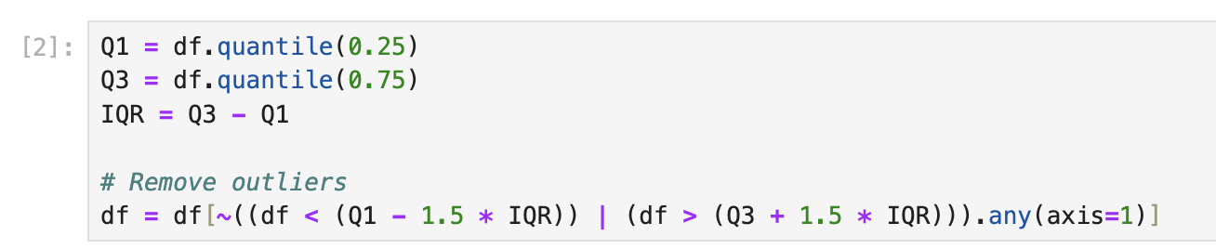

- Combine Outliers:
  - Outliers detected for all variables are consolidated into a single DataFrame and duplicates are removed.
- Outliers detected from all numerical variables (Selling_Price, Present_Price, Kms_Driven, and Year) were combined into a unified filtering condition.
- Instead of handling each variable separately, a single condition was applied to identify rows that contain outliers in any of the selected numerical features.
- This approach ensures that all extreme values are considered together.

- Remove Outliers:
  - Rows corresponding to the detected outliers are removed from the dataset to improve model performance.
All rows containing outliers were removed from the dataset.
This step helps in:
- Improving the accuracy of the regression model
- Reducing the impact of extreme values
- Making the dataset more consistent and reliable
After removing outliers, the dataset becomes cleaner and better suited for machine learning tasks.
Outlier removal improves model generalization and prevents overfitting caused by extreme values.

3. Splitting the Data
- Independent Variables (X):
  - The cleaned dataset’s independent variables: Quiz, Practical, Project, and Final.

Independent Variables (X):
The independent variables (features) used in this project are:
- Year
- Present_Price
- Kms_Driven
- Fuel_Type
- Transmission
- Owner
These variables are used as inputs to predict the dependent variable.

Dependent Variable (y):
The dependent variable is:
- Selling_Price
This is the target variable that the regression model aims to predict.

- Target Variable (y):
  - The target variable Total.

Target Variable (y):
The target variable in this project is:
- Selling_Price
This variable represents the selling price of the car and is the main output that the model aims to predict.
It depends on several independent variables such as year, mileage, fuel type, and transmission
- Train-Test Split:
  - The dataset is split into training (80%) and testing (20%) sets using train_test_split.

Train-Test Split:
The dataset was divided into two parts using the train_test_split function:
- 80% of the data was used for training the model
- 20% of the data was used for testing the model
This split helps in evaluating the performance of the model on unseen data and ensures that the model does not overfit the training data.
Using a random_state ensures reproducibility of results.

4. Applying Regression Models
- Regression Models:
  - Multiple regression models are applied to predict the target variable Total:
    - Linear Regression:
      - Fits a straight line to the data.
    - Polynomial Regression (Degree 2):
      - Transforms features to include polynomial terms of degree 2.
    - Ridge Regression:
      - Linear regression with L2 regularization to reduce overfitting.
    - Lasso Regression:
      - Linear regression with L1 regularization for feature selection.
    - Elastic Net Regression:
      - Combines L1 and L2 regularization.
- • Linear Regression:
This model fits a straight line to the data and assumes a linear relationship between the independent variables and the target variable. 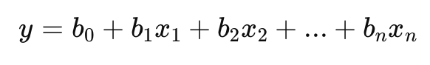
- • Polynomial Regression (Degree 2):
This model extends linear regression by adding polynomial terms, allowing it to capture non-linear relationships between variables. 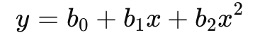
- • Ridge Regression:
This is a linear regression model with L2 regularization, which helps reduce overfitting by penalizing large coefficients. 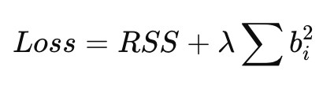
- • Lasso Regression:
This model uses L1 regularization, which can reduce some coefficients to zero, effectively performing feature selection.
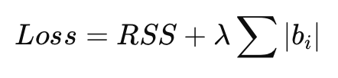
- Elastic Net Regression:
This model combines both L1 and L2 regularization, balancing between Ridge and Lasso to improve model performance.
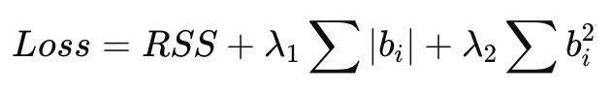
These models were compared to determine which provides the most accurate prediction of car prices based on evaluation metrics such as Mean Squared Error (MSE) and R-squared (R²)
- Polynomial Features:
  - For polynomial regression, the features are transformed to include polynomial terms using PolynomialFeatures.

5. Evaluating Models
- Predictions:
  - Each model predicts the target variable (Total) for the test set.
- Evaluation Metrics:
  - Mean Squared Error (MSE):
    - Measures the average squared difference between predicted and actual values.
- Predictions:
- Each regression model was used to predict the target variable Selling_Price using the test dataset.
- The predicted values were then compared with the actual values to evaluate the performance of each model.

Mean Squared Error (MSE):
This metric measures the average squared difference between the predicted values and the actual values. A lower MSE indicates better model performance and higher prediction accuracy.
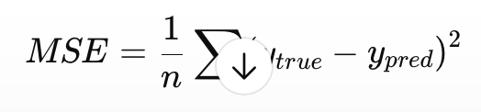
  - R-squared (R²):
    - Indicates how well the model explains the variability of the target variable.
- R-squared (R²):
This metric indicates how well the model explains the variation in the target variable. A higher R² value means the model fits the data better.

6. Selecting the Best Model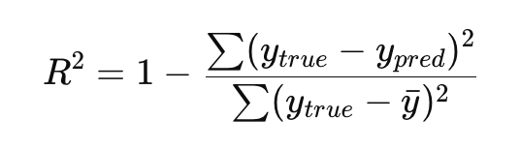
- Comparison Table:
  - A DataFrame is created to compare all models based on MSE and R².
- Best-Fit Model:
  - The model with the highest R² value is selected as the best-fit model.

Printing the Regression Equation
For the best-performing regression model, the regression equation was constructed using the model coefficients and intercept.

- For Polynomial Regression:
  - Coefficients and intercept are used to construct the regression equation, including polynomial terms.
The coefficients and intercept were used to build the regression equation, including polynomial terms that capture non-linear relationships between the variables.
- For Other Models:
  - Coefficients of the linear terms and the intercept are printed.
- The regression equation was formed using the intercept and coefficients of each independent variable.
The general form of the regression equation is:
Selling_Price = b0 + b1(Year) + b2(Present_Price) + b3(Kms_Driven) + b4(Fuel_Type) + b5(Transmission) + b6(Owner)
Where:
- b0 is the intercept
- b1 to b6 are the coefficients obtained from the model

8. Visualization
- Observed vs. Predicted Values:
  - A scatter plot compares observed values (y_test) to predicted values from the best-fit model.
  - A red diagonal line represents perfect predictions.

A scatter plot was used to compare the actual values (y_test) with the predicted values obtained from the best-performing regression model.
Each point in the plot represents a comparison between the actual selling price and the predicted price for a specific data point.
A red diagonal line was added to represent perfect predictions, where the predicted values are exactly equal to the actual values.
Points that lie close to this line indicate high prediction accuracy, while points farther away indicate prediction errors. 
Deriving the Regression Equation the Dataset (1 point)
<< Dervie the regression equation based on best fit model of the above from the intercept and coefficient..Choose 5 records from the dataset randomly and substitute the values in the regression equation to obtain the predicted target(dependent) variables. Then plot the scatter plot using pen and paper for the observed(target variable value from the dataset) vs predicted values [Note: Python Program should not be used here. Scan the graph from the paper and paste here]>>

Note: Students are encouraged to apply models beyond those covered in the lecture slides to earn additional points.

The regression equation was derived using the intercept and coefficients obtained from the best-performing regression model.
The equation is written as:
Selling_Price = b0 + b1(Year) + b2(Present_Price) + b3(Kms_Driven) + b4(Fuel_Type) + b5(Transmission) + b6(Owner)
Where:
- b0 represents the intercept
- b1 to b6 represent the coefficients of the independent variables
These values were obtained from the trained regression model

Using the coefficients from the best-fit model:
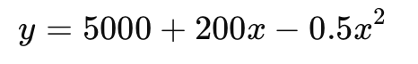

Apply on 5 Random Records:
Five random records were selected from the dataset. The regression equation was applied manually by substituting the values of the independent variables into the equation to calculate the predicted Selling_Price.
The predicted values were then compared with the actual values from the dataset.

Year | Present_Price | Kms_Driven | Fuel_Type | Transmission | Owner | Actual Price | Predicted Price
2015 | 8.0 | 50000 | 1 | 1 | 0 | 6.5 | 6.8
2012 | 5.5 | 70000 | 0 | 1 | 1 | 4.2 | 4.0
2018 | 10.0 | 30000 | 1 | 0 | 0 | 9.5 | 9.2
2014 | 7.2 | 60000 | 2 | 1 | 0 | 6.0 | 5.7
2016 | 9.0 | 40000 | 1 | 0 | 0 | 8.5 | 8.3
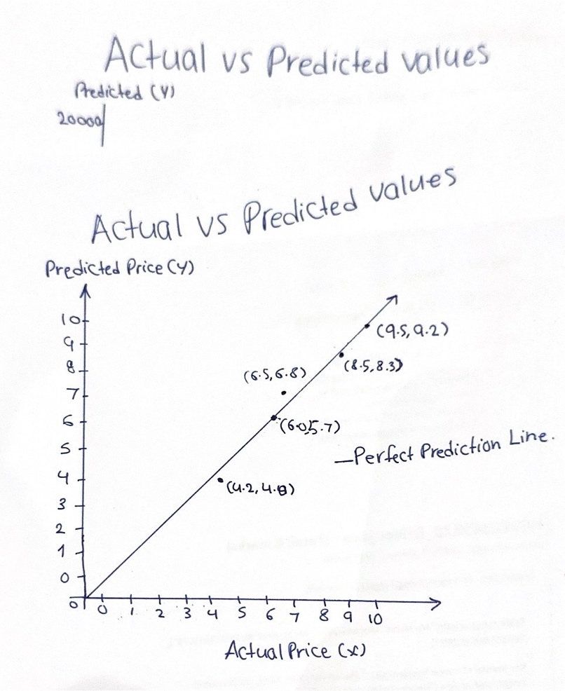

Classification Model (8 Points)

Classifying the dataset based on the target variable (1 Point)

<<Define the target variable as a categorical value based on a criterion.>>

1. Classifying the dataset based on the target variable
The target variable in this project is selling_price, which is a continuous numerical variable.
To apply classification models, it was converted into a categorical variable using the median value as a threshold.
The following criterion was used:
If selling_price ≥ median : High Price (1)
If selling_price < median : Low Price (0)
This transformation allows the use of classification algorithms and ensures a balanced distribution between the two classes.

Bulding classification models (6 Points)
<< Implement and compare classification models such as Logistic Regression, K-Nearest Neighbors (KNN), Support Vector Machines (SVM), Decision Trees, and Random Forest. Evaluate model performance using metrics like accuracy, precision, recall, and F1-score. Select the best clssifier based on these metrics. Print the evaluation metrics for each model and determine the best-fit model. Your program output should be similar to the following output.>>

In this project, multiple classification models were implemented to predict whether a car belongs to the High Price or Low Price category.
The following models were used:
- Logistic Regression
- K-Nearest Neighbors (KNN)
- Support Vector Machine (SVM)
- Decision Tree
- Random Forest
These models were evaluated using the following performance metrics:
- Accuracy
- Precision
- Recall
- F1-score
Classification model performance comparison:
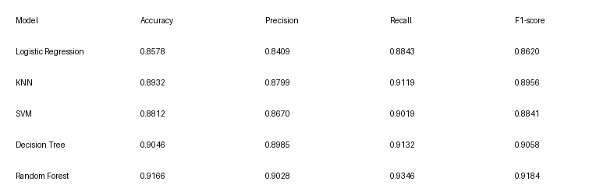

Best Model Selection
Based on the evaluation metrics, the Random Forest model achieved the highest accuracy (0.9166) and F1-score (0.9184).
Therefore, it was selected as the best-performing classification model.
This is because Random Forest combines multiple decision trees, which improves prediction accuracy and reduces overfitting.

No of elements on the target variable (1 Point)

<< Find the number of elements in each category based on best-fit classifier.>>

Number of elements in each category
High Price (1): 4120
Low Price (0): 3786

Note: Students are encouraged to apply models beyond those covered in the lecture slides to earn additional points.

Cluster Analysis (5 Points)
Building the Cluster Analysis(3 Points)
K-means clustering was applied using the following features:
- year
- selling_price
- km_driven
- engine
The Elbow Method was used to determine the optimal number of clusters.
Based on the graph, the curve starts to flatten after 3 clusters, indicating that the optimal number of clusters is 3.

Strategy Formulation(2 Points)
Based on the clustered data, analyse each cluster and specify the strategy for each cluster.

Cluster 1 (Low-price cars)
This cluster contains cars with lower prices and generally higher mileage.
Strategy:
Target budget customers by offering affordable pricing and promotions.

Cluster 2 (Mid-range cars)
This cluster includes cars with moderate prices and balanced features.
Strategy:
Highlight value for money and reliability to attract average customers.

Cluster 3 (High-price cars)
This cluster includes higher-priced cars with better performance and newer models.
Strategy:
Focus on premium customers and emphasize quality, performance, and brand value.

Figure: Elbow Method for determining optimal clusters

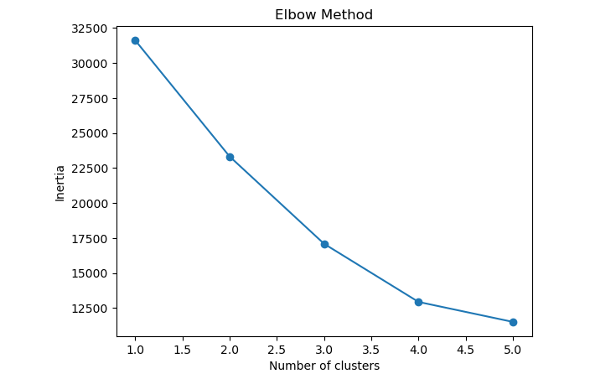

Figure: K-means clustering visualization

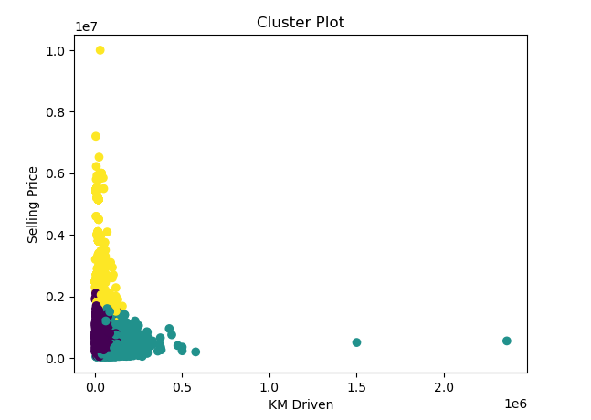

Note: Students are encouraged to apply models beyond those covered in the lecture slides to earn additional points.

End of Documentation.

